Find your way in Copenhagen.

Airport and Transport: | Copenhagen Airport Kastrup is the main international airport serving Copenhagen. The airport is located on the island of Amager, just 8 kilometers (5.0 mi) south of Copenhagen city centre.
Metro | You can reach Copenhagen by train or metro. The metro is located near the terminal 3 exit. All trains go in the same direction from the airport (M2 to Vanløse Station). The trains run with 4-6 minutes intervals during the day and evening. During the night the train runs every 15-20 minutes. It will take you 13 minutes to get to Nørreport Station in the city centre. Tickets can be bought at the metro station and at the DSB ticket sales counter in terminal 3. Please note that the machines only accept coins and credit cards, not notes.
Metro map | 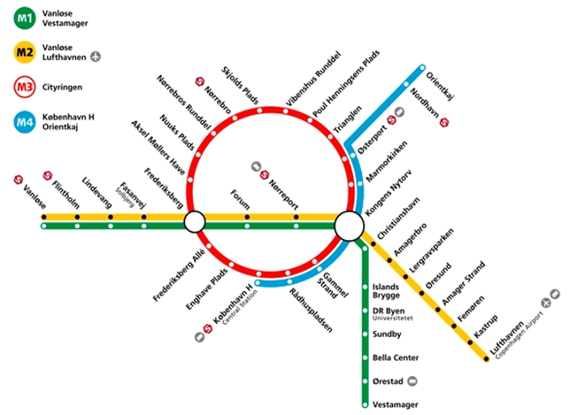
Train | The train station is located by terminal 3. You can take a free shuttle bus from terminal 1 to terminal 3, which will take 5 minutes. The trains run every 10 minutes during the day and will get you to Copenhagen Central Station in about 13 minutes. During the night the trains run 1-3 times an hour. Tickets can be bought at the ticket machines in terminal 3 just above the railway, and at the DSB ticket sales counter, also located in terminal 3. Please note that the machines only accept coins and credit cards, not notes.
Bus | Bus 5A will take you directly to Copenhagen Central Station, City Hall Square, Nørreport and other stations. It takes about 30-35 minutes from the airport to the Central Station. The bus runs every 10 minutes during daytime. The bus runs all night as well, but not so often. Tickets can be bought at the ticket machines in terminal 3, or you can buy a ticket on the bus. Please note that the bus drivers only accept coins.
Taxis | Taxis can pick up passengers at terminal 1 and 3 and will get you to downtown Copenhagen in about 20 minutes depending on traffic. Taxis are usually waiting outside each terminal. It will cost approximately DKK 250-300.
Routes and maps

How to get from the Metro station at
Kongens Nytorv to the National
Museum

How to get from the CABINN Metro  to the National Museum | Walk to the metro station "Bella Center” (about 1.2 km). From there, take the green line on the metro map to Kongens Nytorv. Look at the above map “transport from Kongens Nytorv to the National Museum”.
How to get from hotel ASTORIA  to the National Museum | 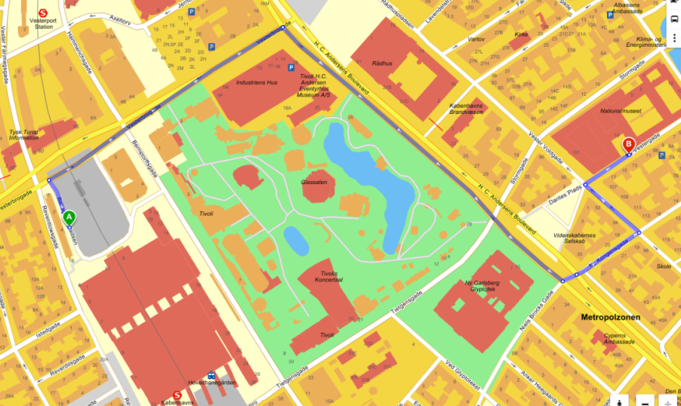  Distance from hotel Astoria to the National Museum is 1.2 kilometer.

